System Architecture:

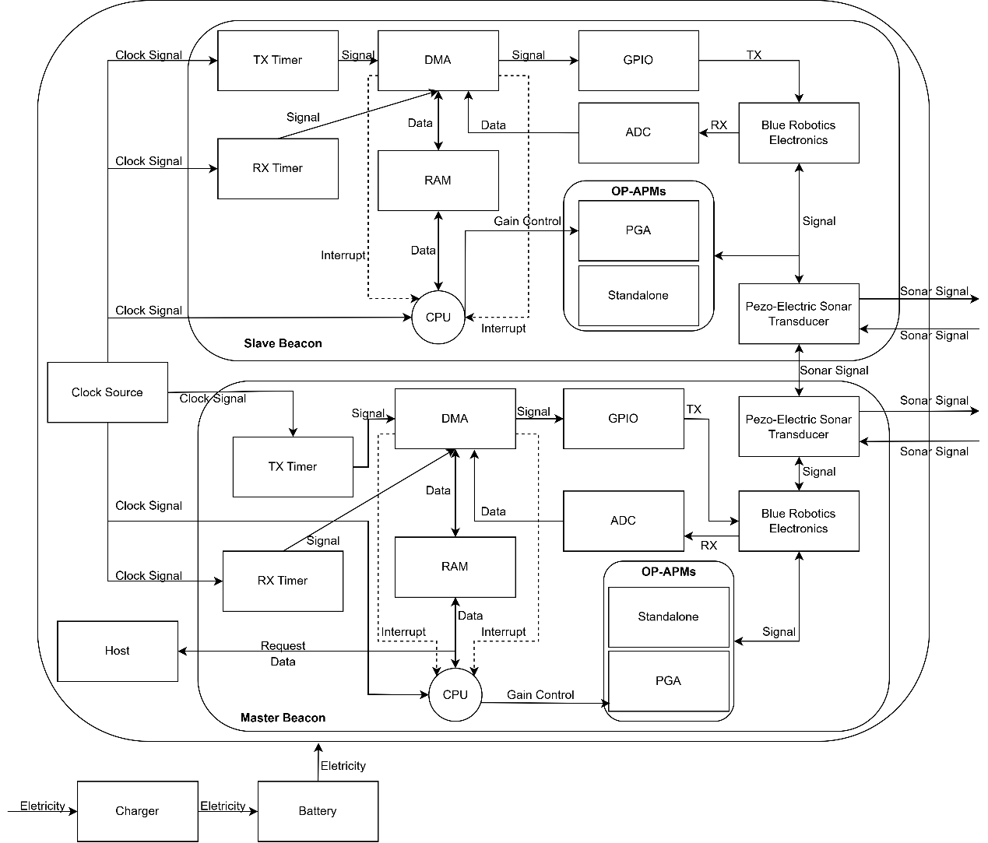

Functional Allocation:

